* 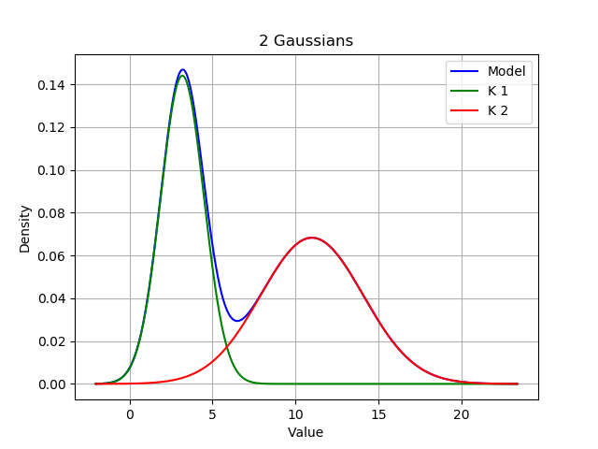
* Log Likelihood: -1091.856560673667
* p_x(x) = 0.471 * N(x, 3.19 | 1.7) + 0.529 * N(x, 11.0 | 9.56)
* 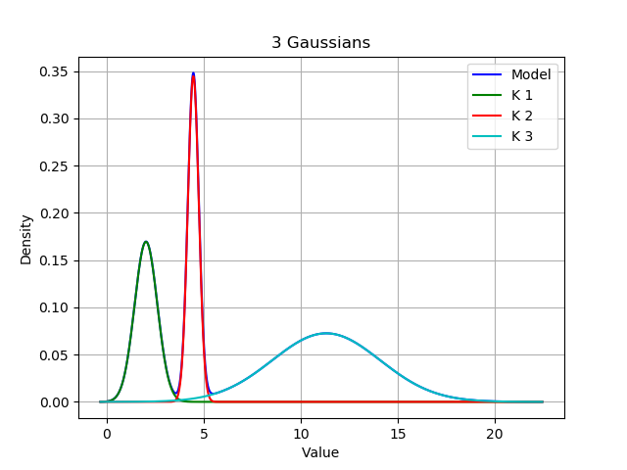
* Log Likelihood: -999.7635118345282
* p_x(x) = 0.249 * N(x, 2.03 | 0.34) + 0.245 * N(x, 4.47 | 0.08) + 0.506 * N(x, 11.32 | 7.74)
* 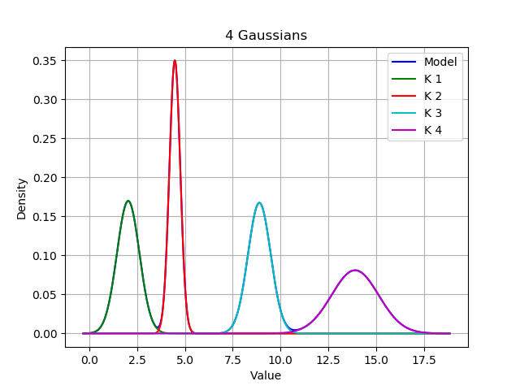
* Log Likelihood: -910.9246936882649
* p_x(x) = 0.25 * N(x, 2.03 | 0.34) + 0.25 * N(x, 4.47 | 0.08) + 0.25 * N(x, 8.89 | 0.35) + 0.25 * N(x, 13.9 | 1.52)
* 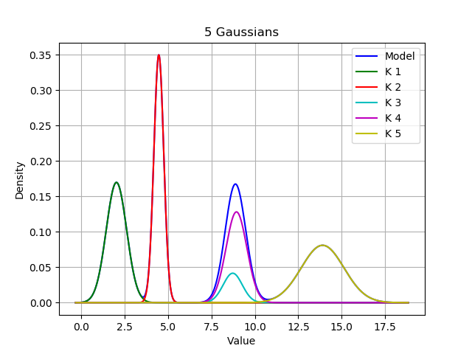
* Log Likelihood: -910.8393241677736
* p_x(x) = 0.25 * N(x, 2.03 | 0.35) + 0.25 * N(x, 4.47 | 0.08) + 0.057 * N(x, 8.73 | 0.3) + 0.192 * N(x, 8.94 | 0.36) + 0.25 * N(x, 13.9 | 1.52)
* 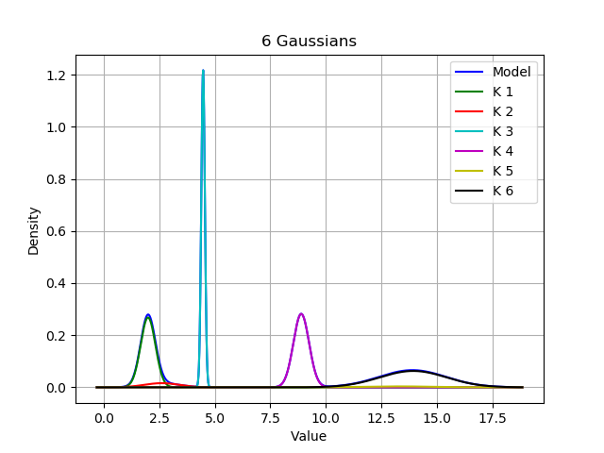
* Log Likelihood: -912.4968389442098
* p_x(x) = 0.224 * N(x, 1.99 | 0.33) + 0.031 * N(x, 2.61 | 0.78) + 0.245 * N(x, 4.47 | 0.08) + 0.249 * N(x, 8.89 | 0.35) + 0.013 * N(x, 13.29 | 1.49) + 0.238 * N(x, 13.93 | 1.51)

I can notice that the lower magnitude Log Likelihoods seem to be a general predictor of the more accurate gaussian model. The LL for 1 Gaussian is absurdly large, and the graph seems profoundly incorrect. However, the LL for 4 Gaussians is just slightly larger than the LL for 5 Gaussians, despite the fact that the graphs would lead to the hypothesis that 4 Gaussians is a better predictor.

By observing the graph with little to no overlap of clusters, and by noting its relatively low Log Likelihood, I believe that there are 4 clusters.